**Week 7.** Write a Python program that blinks an LED at a rate of 3 second ON, 1 second OFF using Raspberry Pi.

**Hardware Requirements**:

1. 2 x jumping wires(male to female)

2. 1 x RaspberryPi

3. 1 x LED, 220Ohm Resistor

4. Breadboard

**Procedure:**

1. Anode of LED to GPIO4 of RaspberryPi

2. Cathode of LED to GND of RaspberryPi

**Circuit Diagram:**

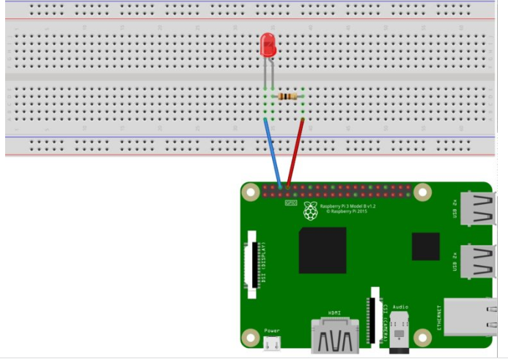

**Program:**

import RPi.GPIO as GPIO # Import Raspberry Pi GPIO library

from time import sleep # Import the sleep function from the time module

GPIO.setwarnings(False) # Ignore warning for now

GPIO.setmode(GPIO.BOARD) # Use physical pin numbering

GPIO.setup(4, GPIO.OUT, initial=GPIO.LOW) # Set GPIO 4 pin to be an output pin and set initial value to low (off)

**while True:** # Run forever

GPIO.output(4, GPIO.HIGH) # Turn on LED

print(“LED ON”);

sleep(3) # Sleep for 1 second

GPIO.output(4, GPIO.LOW) # Turn off LED

print(“LED OFF”);

sleep(1) # Sleep for 1 second

**Note:** save the program with filename along with **“.py”** as file extension.( **example: LED1.py**)

**Raspberry Pi model B+: GPIO Header Details And Pinout:**

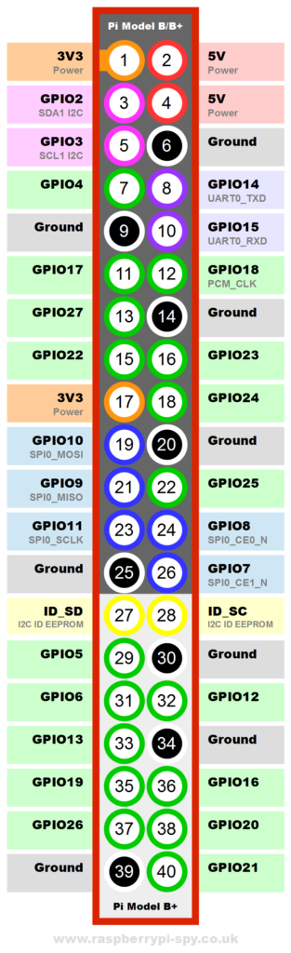

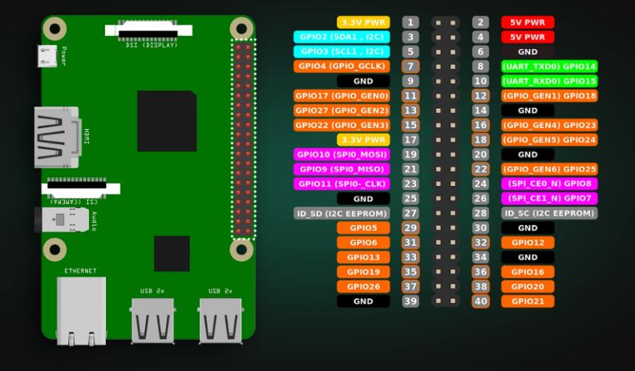

**2. Write a Python program implement Traffic Lights using Raspberry Pi board.**

**Program:**

import RPi.GPIO as GPIO

import time

**# GPIO setup**

RED_LED = 17

YELLOW_LED = 27

GREEN_LED = 22

GPIO.setmode(GPIO.BCM)

GPIO.setup(RED_LED, GPIO.OUT)

GPIO.setup(YELLOW_LED, GPIO.OUT)

GPIO.setup(GREEN_LED, GPIO.OUT)

def traffic_light_sequence():

while True:

**# Red light ON**

GPIO.output(RED_LED, True)

print("Red Light ON")

time.sleep(5)

GPIO.output(RED_LED, False)

**# Yellow light ON**

GPIO.output(YELLOW_LED, True)

print("Yellow Light ON")

time.sleep(2)

GPIO.output(YELLOW_LED, False)

**# Green light ON**

GPIO.output(GREEN_LED, True)

print("Green Light ON")

time.sleep(5)

GPIO.output(GREEN_LED, False)

**# Yellow light ON before red**

GPIO.output(YELLOW_LED, True)

print("Yellow Light ON")

time.sleep(2)

GPIO.output(YELLOW_LED, False)

try:

traffic_light_sequence()

except KeyboardInterrupt:

print("Exiting program")

GPIO.cleanup()

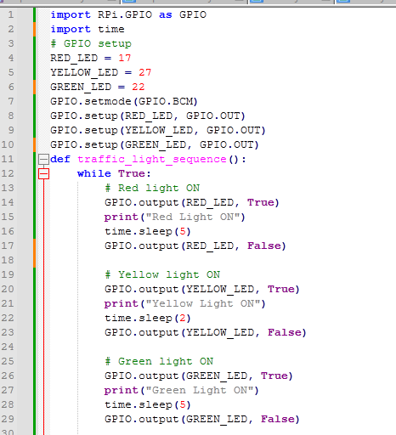

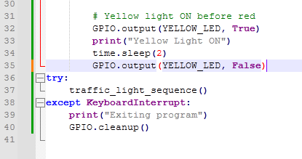

**3. Write a Python program for LED & Buzzer using Raspberry Pi board.**

import RPi.GPIO as GPIO

import time

**# GPIO Pin Definitions**

LED_PIN = 18 # GPIO pin for LED

BUZZER_PIN = 23 # GPIO pin for Buzzer

**# GPIO Setup**

GPIO.setmode(GPIO.BCM)

GPIO.setup(LED_PIN, GPIO.OUT)

GPIO.setup(BUZZER_PIN, GPIO.OUT)

def led_buzzer_alert():

try:

while True:

**# Turn ON LED and Buzzer**

GPIO.output(LED_PIN, True)

GPIO.output(BUZZER_PIN, True)

print("LED and Buzzer ON")

time.sleep(1)

**# Turn OFF LED and Buzzer**

GPIO.output(LED_PIN, False)

GPIO.output(BUZZER_PIN, False)

print("LED and Buzzer OFF")

time.sleep(1)

except KeyboardInterrupt:

print("Exiting program")

GPIO.cleanup()

**# Run the function**

led_buzzer_alert()

**4. Write a Python Code for Traffic Light & Buzzer.**

import RPi.GPIO as GPIO

import time

**# GPIO Pin Definitions**

RED_LED = 17

YELLOW_LED = 27

GREEN_LED = 22

BUZZER = 23

**# GPIO Setup**

GPIO.setmode(GPIO.BCM)

GPIO.setup(RED_LED, GPIO.OUT)

GPIO.setup(YELLOW_LED, GPIO.OUT)

GPIO.setup(GREEN_LED, GPIO.OUT)

GPIO.setup(BUZZER, GPIO.OUT)

def traffic_light_sequence():

try:

while True:

**# Red light ON + Buzzer ON**

GPIO.output(RED_LED, True)

GPIO.output(BUZZER, True)

print("Red Light ON - Buzzer ON")

time.sleep(5)

GPIO.output(RED_LED, False)

GPIO.output(BUZZER, False)

**# Yellow light ON**

GPIO.output(YELLOW_LED, True)

print("Yellow Light ON")

time.sleep(2)

GPIO.output(YELLOW_LED, False)

**# Green light ON**

GPIO.output(GREEN_LED, True)

print("Green Light ON")

time.sleep(5)

GPIO.output(GREEN_LED, False)

**# Yellow light ON before red**

GPIO.output(YELLOW_LED, True)

print("Yellow Light ON")

time.sleep(2)

GPIO.output(YELLOW_LED, False)

except KeyboardInterrupt:

print("Exiting program")

GPIO.cleanup()

**# Run the function**

traffic_light_sequence()